Only fill in the mint green boxes by applicant
Stipulations CCD: ☐ No ☒ Yes, namely: It is not permitted to purchase animals under this licence. Only surplus animals may be used.
Stipulations IvD Utrecht:
- Report changes to the IvDU (info@ivd-utrecht.nl)
- Report unforeseen dead animals and animals with unexpected discomfort to the IvD Utrecht (info@ivd-utrecht.nl) and the animal facility
3. Extra stipulatons:
Approved AWB: name  Date: date | ☐ | Stamp AWB Utrecht | When the animals are not killed immediately: conclusion of work protocol | ☐
Date: Date

Initials:
Number work protocol
 |  |  | When the work protocol is concluded, send a welfare evaluation to info@ivd-utrecht.nl

Unique title of the work protocol
Project number (CCD): | AVD1080020209606 | Principal investigator of the project (name + email) | P.L.P. van Loo, p.l.p.vanloo@uu.nl
Project title: | Gebruik van organen en weefsels ter bevordering van kwaliteit van dierproeven en van in vitro en ex vivo onderzoek (use of organs and tissues to advance the quality of animal experiments and in vitro research)
End date CCD license | 14-5-2025 | Type experiment (appendix CCD project): | Choose
Animal facility: | Choose | If performed in GDL: section(s) | Choose an item.
Planned period for collection of tissue: |  | Date until Date
Indicate below the alarm icon (in numbers) who is the first (1) and second (2) point of contact for animals with unexpected discomfort or animals found dead.
Parties involved: |  | First + last name | Initials | Mobile phone | E-mail | Qualification | Faculty/Institute/ Department
Study Director (SD) |  |  |  |  |  | Art. 9
Alternate Study Director (ASD) |  |  |  |  |  | Choose

Departmental Lab Animal Coordinator
Co-worker |  |  |  |  |  | Choose
Co-worker |  |  |  |  |  | Choose
Co-worker |  |  |  |  |  | Choose
Co-worker |  |  |  |  |  | Choose

Contact person
Animal facility
(Will be filled in by the facility)

Contact person
Animal section
(Will be filled in by the facility)

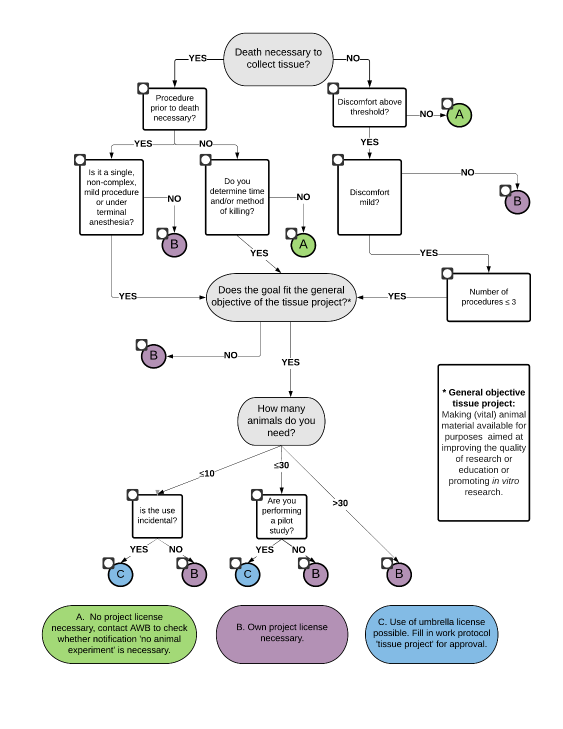
Flow chart for 1.a.1.

 | ☐ |  |  | ☐
 |  |  |  |  |  |  | ☐
 | ☐ | ☐ |  | ☐
 |  |  |  |  |  |  | ☐
 |  | ☐ | ☐
 |  |  |  |  |  |  | ☐
 | ☐
 | ☐ | ☐
 | ☐ | ☐ ☐ |  | ☐ ☐
Explanation flow chart
- Is the death of the animal necessary to obtain the tissue?
If the tissue can be obtained by a procedure that causes no more than mild discomfort to the animal and does not cause permanent damage, death of the laboratory animal is not considered necessary.
- Is a procedure prior to death necessary?
What is meant is, is a procedure prior to death necessary to obtain suitable tissue, for example, an injection for labelling cells.
- Is the discomfort above the threshold?
‘Above threshold’ means all procedures that cause as much discomfort or more than the skilled insertion of a needle. Examples of sub-threshold procedures are: cutting hair or removing cheek mucosa. Examples of above threshold procedures are: an injection or biopsy.
- Does the researcher determine the time and / or method of killing?
When surplus animals are on offer and their death is planned due to redundancy, and the planned time or planned method of killing is changed at the request of or in consultation with the receiving researcher, the answer to this question is YES.
- Is the discomfort more than mild?
If the planned procedures and any discomfort that may result are assessed as more than mild, a separate project licence is required.
- Does the objective of the use of tissue fall within the umbrella objective of this project: namely to improve the quality of the research or education concerned or to promote in vitro / ex vivo research?
- Is the use incidental?
Incidental use is when you want to use a small number of animals (<10) no more than twice a year.
- Are you performing a pilot study?
A pilot is when you want to conduct a pilot experiment no more than twice, for example in preparation of writing your own project application.

1. Description of the experiment (See Guideline experimental design and statistics)

a. Abstract: Please give a short summary (5 sentences) of the experiment with the purpose of the study in simple English.

Also give the short summary in simple Dutch
  - Did you fill in the flow chart above and did it lead to option C? ☐ No ☐ Yes.
If No, this WP is either not necessary to acquire the animal tissue (option A) or you need a separate project licence (option B).
If Yes, is the tissue use incidental or for a pilot study? ☐ Incidental (proceed to question 2) ☐ pilot (proceed to question 1a.2)
Optional explanation
a.2. Give a short description of the study for which this pilot is necessary. Include the added value of the pilot for this study:

2. Animals

a. Species to be used: Choose
 | Breed/strain name | Who do you receive the animals from? | WP number of original use of the animals | Discomfort¹ | Number of animals | Sex | GM | Microbiological status | Date of birth
A |  |  |  | Choose |  | Choose | Choose | Choose
B |  |  |  | Choose |  | Choose | Choose | Choose
C |  |  |  | Choose |  | Choose | Choose | Choose
¹ If animals have experienced severe discomfort, their use is only allowed in studies in which they are killed without prior procedures.

b. Will animals be killed immediately? ☐ No (proceed to question 3) ☐ Yes (proceed to question 7)

3. Housing
Experimental group | Group housing | Bedding | Enrichment | Food¹ | Water¹ | Housing types
 | Choose | Choose | Choose | Choose | Choose | Choose
 | Choose | Choose | Choose | Choose | Choose | Choose
 | Choose | Choose | Choose | Choose | Choose | Choose
 | Choose | Choose | Choose | Choose | Choose | Choose
Are the animals temporarily housed in a way other than the above during the experiment?
☐ Yes, state method and duration:

Explanation of different housing requirements:
¹In case of not standard feed/drinking water: Fill in ‘hazardous substances overview’.

4. Describe consecutive procedures HL seen by AWB ☐

a. Acclimatization: ☐ 1 week ☐ other: please define

b. Tabel 4. Schedule of experimental procedures
Line | Relative day in experiment | Exp. group | Description of the procedure | Duration procedure | Description of discomfort during and as a result of the procedure | Duration discomfort | Estimated level of discomfort | Who
 |  |  |  |  |  |  | Choose
 |  |  |  |  |  |  | Choose
 |  |  |  |  |  |  | Choose
 |  |  |  |  |  |  | Choose
 |  |  |  |  |  |  | Choose

5. Anaesthesia and analgesia

a. Will anaesthesia be administered? ☐ No ☐ Yes; please fill out the table below.
Anaesthesia | Substance (including brand name) |  | Route of administration | Dose
Premedication agent
Introductory agent
Maintenance agent
Optional:
Antagonize agent
Ventilation with intubation: |  | ☐ No ☐ Yes
How is the depth of anaesthesia monitored?
Optional: explanation anaesthesia

b. Will analgesia be administered? ☐ No ☐ Yes: If so, please fill out the table below
Analgesia | Procedures | Substance (optional brand name) | Route of administration | Dose | Interval | Duration
Pre-surgical agent
Agent during surgery

6. Welfare check and humane end point

a. Regular welfare check
Starting point is that the animal and the accommodation are checked daily at all times (from the moment the animals enter the facility). This is a routine check for calamities.
At least once per 7 days a thorough check of the animal’s welfare is performed on the basis of behaviour, posture, gait/mobility, food intake/weight loss, grooming/auto mutilation and other striking clinical symptoms. Findings of this welfare check are noted in the Welfare Logbook.

b. Humane end point / Premature withdrawal of animal(s)
When a humane end point (HEP) is applied, the experiment is prematurely terminated for an individual animal or a group (i.e. before the planned end of the experiment). The goal of the HEP is to prevent avoidable discomfort. There can be three reasons to apply a HEP. You are requested to indicate for I and II which criteria you use.

I. The discomfort of an individual animal that is inherent to the experiment exceeds the maximum discomfort described in the project
Describe for which clinical symptoms (specify degree and seriousness) and on basis of what criteria (optional) a HEP is applied.

Describe the HEP also in Dutch

II. The scientific goal is reached
Describe –on animal level– when the scientific end point has been reached and what the criteria are to withdraw an animal from the experiment.

III. The scientific goal can no longer be reached
For example: an animal is found to be unsuitable for sampling

7. Estimated maximum discomfort per experimental group
Experimental group | Estimated maximum discomfort | Description of discomfort (on the basis of type and number of procedures – see table 5.b- and clinical symptoms- see table 6.b))
 | Choose
 | Choose

8. Destiny of animals at the end of the experiment
If the laboratory animals are suitable for reuse or relocation afterwards, or if you do not need the whole animal for further research, then make the animals, or tissues thereof, available via the Animal and Tissue Exchange platform (ATEX).

Experimental group | Destiny | If euthanasia: method
 | Choose | Choose
 | Choose | Choose
 | Choose | Choose

Clarification other method of euthanasia

Table Code numbers according to NVWA-registration
Please provisionally fill in the table below! For codes, see next page.

The Study Director is obliged to send the fully completed welfare evaluation form (in which the table below is included with the actual discomfort experienced (column 12)) to the AWB (info@ivd-utrecht.nl) and to the animal welfare coordinator of his own department within two weeks after the conclusion of the work protocol or in the interim when entering a new calendar year. From this the data for the statutory required annual registration are taken.

OWE department: IvD Utrecht (10888)
VGH:
Utrecht University: 10800
UMC Utrecht: 11500
HAS 's Hertogenbosch: 73200
Hogeschool Utrecht: 72100
Evidensia: 28700
STENTiT: 22900
Utrecht Premedical: 28800

If the correct licence holder is not listed here, the data should be submitted to the IvD of your own institute.
EU Submission | Number VGH | CCD nr | OWE | Animal Species | Specify other (in Latin) | Number of Animals | Re-use | Place of birth | NHP Place of birth | NHP Colony type: Self-sustaining colony | NHP Generation | Genetic status | Creation of a new GA line | Purpose | Specify other | Type of legislation | Specify other | Origin of legislation | Severity | Custom Severity | Explanation of warnings | Comments (in English) | Method of tissue sampling | Specify other method | Severity of genotyping | Anaesthesia | Analgesia | Kill without prior intervention | State after experiment | Work protocol number | Field 6
Choose | 10800 | AVD1080020209606 | 10888 | Choose |  | Enter number | [Y] Yes |  |  |  |  | Choose | [N] | Choose |  |  |  |  | Choose |  |  | Enter text |  |  |  | Choose | Choose | Choose | Choose | Enter tekst | Enter tekst
Choose | 10800 | AVD1080020209606 | 10888 | Choose |  | Enter number | [Y] Yes |  |  |  |  | Choose | [N] | Choose |  |  |  |  | Choose |  |  | Enter text |  |  |  | Choose | Choose | Choose | Choose | Enter tekst | Enter tekst
Choose | 10800 | AVD1080020209606 | 10888 | Choose |  | Enter number | [Y] Yes |  |  |  |  | Choose | [N] | Choose |  |  |  |  | Choose |  |  | Enter text |  |  |  | Choose | Choose | Choose | Choose | Enter tekst | Enter tekst
Choose | 10800 | AVD1080020209606 | 10888 | Choose |  | Enter number | [Y] Yes |  |  |  |  | Choose | [N] | Choose |  |  |  |  | Choose |  |  | Enter text |  |  |  | Choose | Choose | Choose | Choose | Enter tekst | Enter tekst
Choose | 10800 | AVD1080020209606 | 10888 | Choose |  | Enter number | [Y] Yes |  |  |  |  | Choose | [N] | Choose |  |  |  |  | Choose |  |  | Enter text |  |  |  | Choose | Choose | Choose | Choose | Enter tekst | Enter tekst
Choose | 10800 | AVD1080020209606 | 10888 | Choose |  | Enter number | [Y] Yes |  |  |  |  | Choose | [N] | Choose |  |  |  |  | Choose |  |  | Enter text |  |  |  | Choose | Choose | Choose | Choose | Enter tekst | Enter tekst
Choose | 10800 | AVD1080020209606 | 10888 | Choose |  | Enter number | [Y] Yes |  |  |  |  | Choose | [N] | Choose |  |  |  |  | Choose |  |  | Enter text |  |  |  | Choose | Choose | Choose | Choose | Enter tekst | Enter tekst
Choose | 10800 | AVD1080020209606 | 10888 | Choose |  | Enter number | [Y] Yes |  |  |  |  | Choose | [N] | Choose |  |  |  |  | Choose |  |  | Enter text |  |  |  | Choose | Choose | Choose | Choose | Enter tekst | Enter tekst
Choose | 10800 | AVD1080020209606 | 10888 | Choose |  | Enter number | [Y] Yes |  |  |  |  | Choose | [N] | Choose |  |  |  |  | Choose |  |  | Enter text |  |  |  | Choose | Choose | Choose | Choose | Enter tekst | Enter tekst
Choose | 10800 | AVD1080020209606 | 10888 | Choose |  | Enter number | [Y] Yes |  |  |  |  | Choose | [N] | Choose |  |  |  |  | Choose |  |  | Enter text |  |  |  | Choose | Choose | Choose | Choose | Enter tekst | Enter tekst

